Renting the Guarantee: How the Banco Master Machine Worked
Oct 30, 2026 · @Guilherme

A CDB that paid too much
In 2024, Banco Master’s CDBs paid up to 140% of the CDI, and 150% in some issues, while the market average sat around 100–107% [1]. Ordinary savers bought them through large investment platforms such as XP and BTG Pactual [2].
They did not need to trust Master. The FGC, Brazil’s deposit-guarantee fund, financed mainly by its member banks [5], covered up to R$250,000 per CPF or CNPJ [3]. The rate was the bank’s; the safety was the fund’s.
When the Central Bank liquidated Master on November 18, 2025, the FGC owed about R$40.6 billion to roughly 800,000 investors, the largest payout in its history [4]. The previous record, Bamerindus in 1997, was R$19.6 billion [5].

The argument in brief
Master is best explained as a control fraud built on a deposit guarantee. Economists call the pattern “looting”: owners of a firm whose debts someone else guarantees gain more by extracting cash and defaulting than by running it well [6]. In the cases Akerlof and Romer studied, the guarantor was usually the government [6]; here it was the FGC, funded mainly by the banks [5]. Looting needs two conditions: guaranteed funding, and the ability to carry assets above their real value [7].
On this reading, the people who controlled Master used the FGC to raise retail money, inflated the balance sheet, drew cash out, and paid for time and access. When the money ran short, they tried to pass the hole to BRB, a bank controlled by the Federal District government. Public money had already entered through state and municipal pension funds, which bought Master paper that the FGC did not cover [96]. This reading is the author’s inference from findings by regulators, police and the liquidator.
None of it has been tried in court. On October 28, 2026, the Federal Police (PF) indicted 15 people in its first inquiry, on suspected charges including criminal organization, money laundering and fraudulent management [8]. Vorcaro denies fraud and calls his imprisonment unjust [9].
- Established: the Central Bank liquidated the conglomerate on November 18, 2025, citing a severe liquidity crisis and serious violations of financial-system rules [10].
- Alleged: the fraud, the extraction, the payments and the coercion described below.
- Unknown: when the intent began, who really held control, the full list of payments, and how much of the phone evidence will survive court challenge.

The machine at a glance
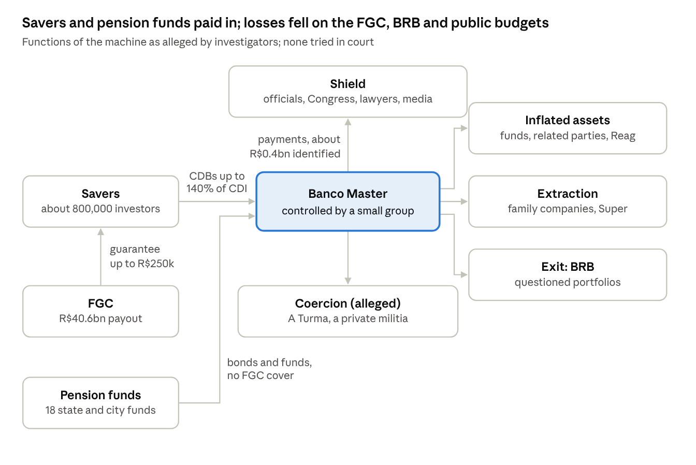
the Master machine · 7 functions and the flows between them
Savers’ money came in on the FGC’s guarantee, and pension funds’ money without it; it flowed into inflated assets, out to insiders and, at the end, toward BRB, while payments bought protection.

Who mattered, and how much
Eight people or groups ran the engine, and a handful acted on its control points. Most of the famous names are accessory: they show how far the network reached, not how the machine worked.
The tiers rank documented function, not guilt, fame or amount:
- Central: raised, inflated, moved or offloaded the money. Without them the engine stops.
- Secondary: acted on a control point (supervision, the guarantee’s rules, the buyer, or critics) without being part of the engine.
- Accessory: contacts and spending around the engine, with no documented act on it.
A R$500,000 monthly payment to a supervisor ranks above a R$64 million film, because it touched a control point. One new finding can move a name up; the table says where that could happen.
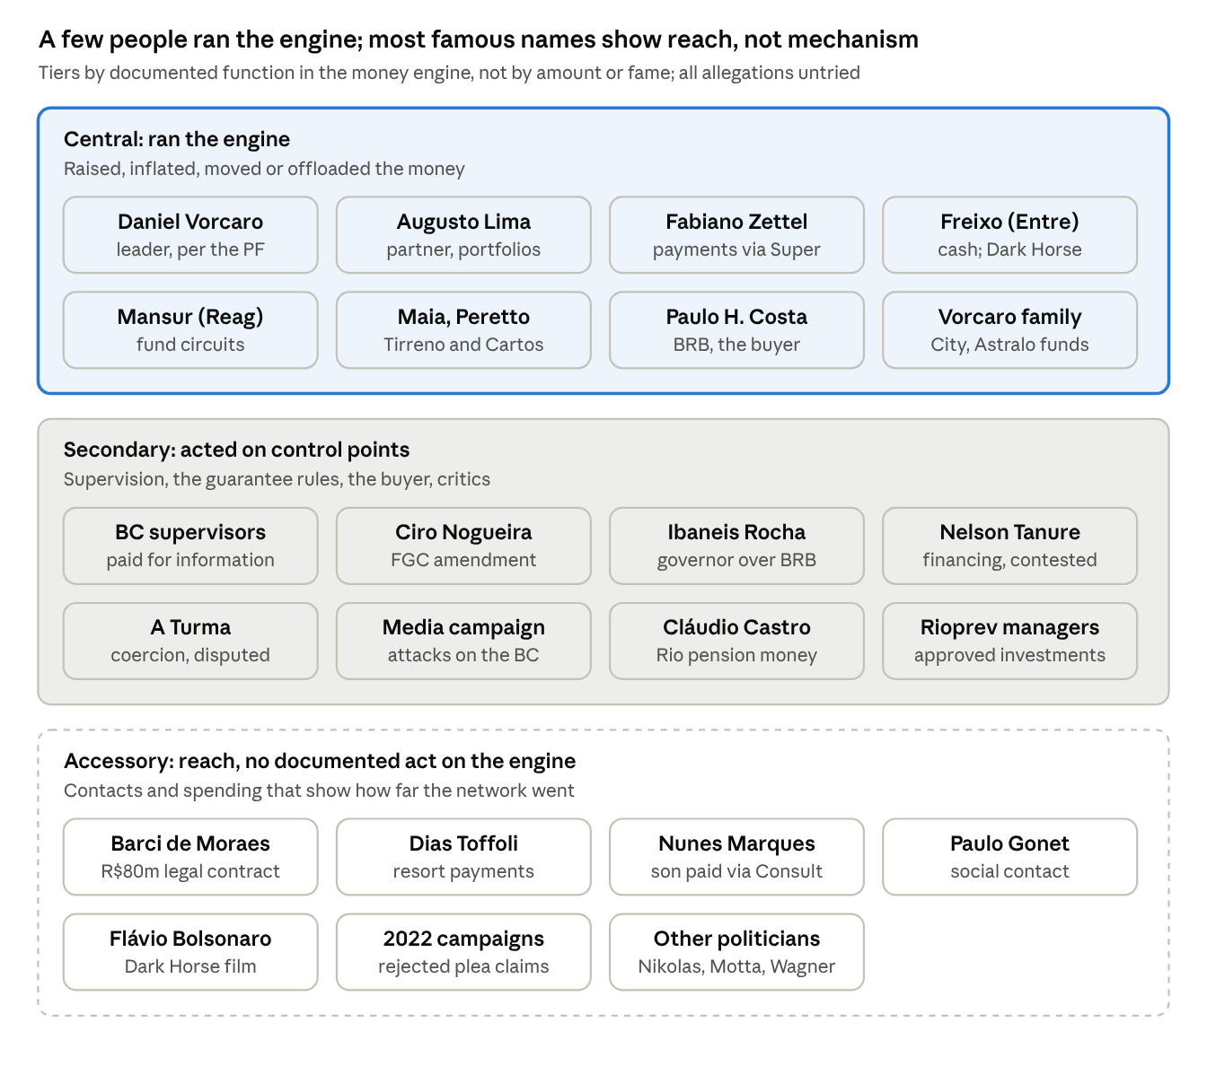
the cast by tier · central, secondary, accessory
Read top to bottom: the further down a name sits, the less its removal would have changed where the money came from or went.
Actor | Tier | Part attributed (alleged unless stated) | Response
Daniel Vorcaro | Central | Led the scheme, per the PF [62] | Denies fraud [9]
Augusto Lima | Central | Partner; executive-financial core; credited by the PF with the fake portfolios [62][46] | Denies [46]
Fabiano Zettel | Central | Payment hub: received R$485m from Super Empreendimentos [27] | No response retrieved
Antonio Carlos Freixo Jr. (Entre) | Central | Generated about R$1.3bn in cash for Vorcaro in 2020–2025 and sent US$12.3m to Havengate, per his approved plea [84] | Says the plea was voluntary [84]
João Carlos Mansur (Reag) | Central | Fund circuits behind R$11.5bn of flawed operations, per the BC [18][19] | Plea signed, awaiting approval [67]; denies PCC links [23]
André Maia, Henrique Peretto (Tirreno, Cartos) | Central | Origin of the questioned portfolios [82]; Maia indicted [83] | Cartos says it had no operations with Master [82]
Paulo Henrique Costa (BRB) | Central | Bought the portfolios; strategic core with Vorcaro [50]; suspected of receiving R$140–146.5m [49][87] | Denies any loss to BRB [87]
Henrique Vorcaro and family vehicles | Central | Extraction through City, Navarra and Astralo 95; R$2.2bn allegedly hidden [26][29][89] | No response retrieved
Former BC supervision officials | Secondary | Paid for inside information, per the PF [31] | No response retrieved
Senator Ciro Nogueira (PP) | Secondary | Monthly payments; filed the FGC amendment drafted by Master’s staff [33][55] | Rejects any wrongdoing [40]
Ibaneis Rocha, then DF governor | Secondary | Headed BRB’s controlling shareholder; Costa told the PF he knew everything; not indicted [85] | Says he knew of no fraud until the liquidation [86]
Cláudio Castro, then RJ governor | Secondary | Allegedly aligned with Vorcaro as Rioprevidência put about R$3bn into Master bonds and funds; trips and a dinner paid by Vorcaro, per the PF [99][100][101] | Denies any improper relationship; says the investments followed the fund’s technical process [102]
Rioprevidência managers | Secondary | Approved the investments against the fund’s earlier conservative policy, per the PF [103] | The fund denied wrongdoing [98] and says it recovered R$1.4bn [106]
Nelson Tanure | Secondary; central if proven | Allegedly financed capital injections through convertible debentures [63] | Denies any stake [65]
“A Turma” | Secondary | Surveillance and intimidation of critics [58] | Defense disputes it exists [61]
Media and influencer campaign | Secondary | Paid attacks on the BC; R$51.9m to Metrópoles [35][37] | Publicist confirmed paying influencers [37]
Barci de Moraes law firm | Accessory | R$80m under a legal-services contract [34] | Says it gave real legal services; the PF report does not conclude wrongdoing by the justice or his wife [34][41]
Justice Dias Toffoli | Accessory | R$20–35m paid to a resort structure where his family company had been a partner [71][72] | Denies receiving anything from Vorcaro or Zettel [71]; colleagues called the PF report “legal garbage” [73]
Justice Nunes Marques | Accessory; secondary if the vote link holds | R$6.6m to a consultancy that paid his son; a R$1.45m Carnival stay for “KN”; messages tie payments to a sugar-mill vote touching Master’s precatórios [74][76] | Denies voting on Master cases or his son taking Master money [74]; says he never asked Vorcaro for anything [75]
Prosecutor-General Paulo Gonet | Accessory | Social contact through a lawyer; no payments reported [78] | Denies friendship; MPF council declined to investigate, 5–4 [77]
Senator Flávio Bolsonaro (PL) | Accessory | Asked Vorcaro to fund Dark Horse; US$12.3m sent [84]; target of a Supreme Court inquiry [79] | Calls it private sponsorship [79]
2022 campaigns | Accessory | Donations called bribes in a rejected plea [38] | Those named deny it [38]
Nikolas Ferreira, Hugo Motta, Jaques Wagner | Accessory | A request for help, visits to Vorcaro’s house, concert tickets [81][27][21] | Nikolas denies receiving money [81]; others not retrieved
Every tier rests on untried allegations and will change as courts rule.

1. Funding: renting the FGC’s credibility
Master’s funding rested on the guarantee by design. Vorcaro told the PF that the business plan he gave the Central Bank in 2018 was entirely tied to the FGC, which he called the rules of the game [11].
Regulators noticed. The CVM’s interim president said one of the market’s first concerns was the bank’s use of the FGC as a lever to raise money [12].
Not all of the money was insured. Eighteen state and municipal pension funds bought R$1.876 billion of Master’s letras financeiras, bank bonds the FGC does not cover [96]; a section below follows that money.
The balance sheet grew fast. Equity went from R$219 million in 2021 to R$4.7 billion in 2024, a year with a reported R$1 billion profit [13]. The investigations below call much of that value into question.
The model did not hold. The PF says new CDBs were issued to repay earlier investors, a pattern comparable to a pyramid [14]. A Central Bank technical note dates the breakdown to November 2024, when Master could no longer earn enough to pay its CDB holders [15].

2. Inflating the balance sheet
The second job was to make assets look worth more than they were. The CVM’s interim president said signs appeared as early as 2020 of assets placed in one fund and later sold to another at a steep markup [12].
A CVM investigation reported by Estadão found Master put R$2.1 billion into ten companies without the economic capacity to justify it, between 2022 and 2025 [16]. Investigators also found more than R$3.5 billion placed in funds Master managed, R$1.8 billion of it in notes from companies tied to partners [17]. Loans to companies came back to the bank as purchases of its own CDBs [17].
The fund manager Reag was a central circuit. The Central Bank told the TCU that Reag-managed funds structured fraudulent operations with Master between July 2023 and July 2024 [18]. The suspect transactions totaled R$11.5 billion [19].
Investigators say money moved within minutes through funds tied to the same intermediaries, ending in near-worthless paper such as notes of the long-defunct Besc [20]. Reag’s founder, João Carlos Mansur, says in his plea proposal that Reag served Master from 2019 [21].
Reag was also a target of Carbono Oculto, an investigation into PCC money laundering, suspected of laundering up to R$1 billion for the faction [22]. Mansur denies any link to the PCC [23].
Not every asset was fake. Master held precatórios, court-ordered government debts that can take years to be paid [2]. When BRB later received Master assets, it booked the Credcesta payroll-loan portfolio 45% above Master’s own value, while marking an Oncoclínicas loan down 52% [24].

3. Extraction: from the bank to the family
The third job was to move money out. Folha reported investigators’ view that Master became a money-making machine for Vorcaro, his relatives and his partners [25].
The clearest documented case predates the cash crunch. In 2022, City, a Master-linked fund, paid R$419.9 million to Vorcaro family companies for receivables promising R$798 million later [26]. The liquidator says those receivables had no real backing [26].
In July 2025, City sold the whole package for R$776.9 million to a company called Navarra. The liquidator found Navarra’s final beneficiary was Vorcaro himself, through the Lunar and Astralo 95 funds [26]. The suspicion is that the sale hid the family’s debt in the books [26].
Payments ran through Super Empreendimentos e Participações. Vorcaro’s brother-in-law, Fabiano Zettel, received R$485 million from it between July 2022 and January 2026; the PF sees his role as central to financing the group [27]. A fund targeted in Carbono Oculto also sent R$180 million to Super [28].
The PF says extraction continued after the fall: after his first release, Vorcaro allegedly hid R$2.2 billion from creditors in an account linked to his father [29]. São Paulo federal prosecutors see a criminal organization structured since the last decade; the defense says no operation benefited relatives or third parties [30].
Cash moved too. Antonio Carlos Freixo Jr., owner of Entre Investimentos, generated about R$1.3 billion in cash for Vorcaro between 2020 and 2025, according to g1’s account of his approved plea [84].
Courts have begun to act on the liquidator’s claims. In March 2026, a São Paulo bankruptcy court barred the sale of assets held by Astralo 95 and other vehicles, citing atypical transfers before the liquidation, including R$285.8 million moved between funds [89]. A freeze reflects signs of diversion, not a final finding.
Abroad, the liquidator seeks to annul Vorcaro’s January 2024 transfer of a US$25.8 million Miami penthouse to his ex-wife, calling it simulated [90]. In May 2026, a Florida bankruptcy judge paused the probe of a US$32 million mansion until he rules on jurisdiction [91].

4. The shield: buying time, rules and reputation
Payments identified so far to officials, politicians, lawyers and media come to about R$0.40–0.42 billion, about 1% of the FGC payout (author’s arithmetic, below). Their size says cost of doing business. Their targets say more: they sat at the points that could stop the machine, or enlarge it.
Recipient (alleged) | Amount | Basis of the claim
Former head of Central Bank supervision | Recurring R$500,000 payments | PF report [31]
Current and former PF agents | Up to R$400,000 a month | PF [32]
Senator Ciro Nogueira (PP) | R$300,000–500,000 a month; R$18.85m frozen by court order | PF [33]
Barci de Moraes, law firm of Justice Moraes’s wife | R$80m in 22 monthly installments, Feb 2024–Nov 2025 | Master’s tax filings [34]
Structure owning the Tayayá resort, where Justice Toffoli’s family company had been a partner | R$20–35m | PF reading of Vorcaro–Zettel messages [71][72]
Consult, a consultancy that paid Justice Nunes Marques’s son | R$6.6m, Aug 2024–Jul 2025 | Coaf [74]
Carnival 2025 stay for “KN” | About R$1.45m | Messages; the PF links “KN” to Nunes Marques [76]
Metrópoles news portal | R$51.9m | PF messages; Coaf alert [35]
DCM website | R$50,000 a month | PF [36]
Digital influencers | Offers of up to R$2m each | PF; the paying publicist’s testimony [37]
2022 election campaigns | R$5m declared + R$10m in cash | Vorcaro’s rejected plea proposal [38]
Dark Horse, a biopic of Jair Bolsonaro | US$12.3m (about R$64m) | Freixo’s approved plea; Crédito Oculto operation [84][39]
Tickets for Senator Jaques Wagner (PT) | R$63,300 | Mansur’s plea proposal [21]
Cláudio Castro, then Rio de Janeiro governor | Trips, some abroad; a New York dinner in May 2023 (US$13,000 in the report’s text) | PF [100][101]
Those named dispute the claims. Nogueira’s defense rejects any suggestion of wrongdoing [40]. The law firm says it gave Master broad legal advice and representation [34], and the PF report does not conclude that the justice or his wife broke the law [41].
Toffoli says he never received money from Vorcaro or Zettel; his office says his family company left the resort in February 2025 [71]. Nunes Marques denies voting on Master cases and says his son received no Master money; his son says Consult paid him R$281,600 for tax work [74].
Reports differ on the firm’s related contracts with Vorcaro companies: R$208 million in total [42], or R$180 million [43]. Senator Flávio Bolsonaro asked Vorcaro to fund Dark Horse; he is the target of a Supreme Court inquiry and calls it private sponsorship [79]. Augusto Lima, Vorcaro’s former partner, has documented ties to the PT in Bahia [44].
Access was also built socially. Vorcaro received politicians, including Nogueira and Deputy Hugo Motta, at a R$36 million Brasília house registered to Super; his office says he rented it [27]. Prosecutor-General Paulo Gonet appears in messages relayed by a lawyer about a London tasting; no payments have been reported, and the MPF council declined, 5–4, to investigate him [77][78]. Hosting or meeting officials is not, by itself, evidence of wrongdoing.
The arithmetic. The identified totals are R$140–146.5 million alleged for BRB’s former president (next section), R$80 million, R$64 million, R$51.9 million, R$20–35 million to the resort structure, R$18.85 million frozen, R$15 million in alleged donations, R$6.6 million to Consult and R$1.45 million for the Carnival stay. Together: about R$0.40–0.42 billion, or about 1% of the R$40.6 billion payout [4]. Adding the R$485 million that passed through Zettel [27], which overlaps, gives about 2%. Who mattered does not follow these amounts; see the tiers above.

5. The exit: BRB and the guarantee itself
When funding dried up, the strategy shifted from extracting value to moving the loss. The buyer was BRB, the bank controlled by the Federal District government.
Fake portfolios. Operations with BRB began in the second half of 2024 [45]. The core portfolios came from Tirreno, a shell company created in December 2024 and controlled by Cartos [46]. Master took Tirreno’s credits without paying anything and resold them to BRB [47].
Between January and June 2025, BRB bought R$6.7 billion of these portfolios and paid R$5.5 billion in premium, R$12.2 billion in all [48]. The PF puts BRB’s total transfers to Master at about R$17 billion [46].
Inside BRB. The PF says BRB’s leaders knew of fraud suspicions from the start and kept the contracts despite internal alerts [45]. Former president Paulo Henrique Costa is suspected of receiving R$140 million from Vorcaro [49]. The PF places him with Vorcaro in the scheme’s strategic core [50]; Costa has said there is no evidence the portfolios were rotten [48].
Investigators later put the alleged payments to Costa at R$146.5 million, in properties [87]. Costa told the PF that Ibaneis Rocha, then governor of the Federal District, knew everything happening at the bank; the PF is examining his role, but he is not indicted [85]. Ibaneis says he knew of no fraud until the liquidation and blames Costa [86].
The swap and the loss. About R$10 billion was later swapped for other Master assets, leaving R$2.6 billion uncovered, which the Central Bank ordered BRB to provision [51]. Central Bank staff estimate the loss could exceed R$5 billion [52]. R$12.2 billion is the face value of the questioned portfolios, not the loss.
The defense. Vorcaro says the sale caused BRB no loss, that he swapped in his own assets below their value, and asks for an independent appraisal [9]. He blames BRB’s difficulties on the “hasty” launch of the PF operation [88].
The merger. As reported from the court file, acquiring Master would have let BRB dilute the fictitious portfolio inside a larger balance sheet [53]. The Central Bank vetoed the deal in early September 2025 [54].
The guarantee itself. The PF says Master’s staff drafted an amendment raising FGC coverage from R$250,000 to R$1 million per depositor, delivered to Nogueira’s office and reproduced in full [55]. Vorcaro allegedly said it came out exactly as he ordered; contacts said it could multiply the bank’s business sixfold [56]. Whether the amendment advanced was not checked for this article.
The end. Vorcaro was arrested on the night of November 17, 2025 [54]. Investigators told Folha his jet was bound for Malta, and that the announced sale to the Fictor group was staged to cover the trip [57].

Public pension funds: fuel, then a place to park
Public pension funds gave Master uninsured money in two waves: first as long-term fuel, then, after the model broke, as a place to park assets. They were sources of money for the scheme, not its target.
Eighteen of Brazil’s 2,130 state and municipal pension funds bought R$1.876 billion of Master’s letras financeiras between October 2023 and December 2024 [96]. Unlike CDBs, these bonds have no FGC cover [96]. The largest buyers were Rioprevidência, Rio de Janeiro’s state fund (R$970 million), Amapá (R$400 million) and Maceió (R$97 million) [96]. Officials cited returns above 130% of the CDI [98].
Phase | What the funds put money into | Role in the machine
Oct 2023–Jul 2024 | Master’s own bonds; Rio’s mature in 2033–2034 [96][97] | Fuel, like CDBs but locked in for a decade
Dec 2024–Oct 2025 | R$2.01 billion from Rioprevidência into structured funds of the same group, “set up to get around regulatory restrictions,” per Justice Mendonça [103] | A place to park assets after the model broke
Oct 2025 | A planned swap of Rioprevidência’s bonds for state credit rights or fund quotas: “Faremos o mesmo em Maceió” [105] | The BRB move: shifting the hole out before liquidation
Why the bonds were good fuel. A scheme that pays old creditors with new money [14] runs best on money that will not ask to come back. A pension fund also moves hundreds of millions in one decision, with no R$250,000 cap, through a handful of appointed managers. That last feature is a control point (author’s inference).
Where the losses arose. In the late funds, losses arose inside the funds themselves. Rio’s state attorney sued in July 2026 to recover R$641.4 million. It ties R$135.1 million to an alleged scheme to inflate Ambipar shares, and R$481.4 million to rule changes that removed investors’ votes and added four years to repayment [106]. There, if the claims hold, value moved out of the pension fund directly.
Not all of it is lost. Rioprevidência says it recovered R$1.4 billion from a Master-run fund in December 2025 [106]. Its R$970 million in bonds waits in the liquidation queue, which can take years [104].

Rioprevidência and Cláudio Castro
The PF puts Rioprevidência’s exposure at about R$3 billion while Cláudio Castro was governor; another report gives R$3.6 billion [98][99]. Eucherio Lerner Rodrigues became investment director on October 4, 2023, the same day Master filed for accreditation with the fund [103].
The state audit court found R$2.6 billion exposed, over 25% of the fund’s assets, with about R$1 billion added after its May 2025 alert [98]. It barred new Master investments on October 8, 2025 [105].
The PF cites messages tying the investments to “political alignment” with the governor, meetings close to the investments, and trips partly paid by Vorcaro [99][100]. They include a New York dinner in May 2023 that, according to the investigation, Vorcaro paid for [101]. Justice Mendonça saw a “robust set” of circumstantial evidence, and the PF searched Castro, by then a former governor, on May 26, 2026 [99][98].
Castro denies any improper relationship and says his contacts with Vorcaro were institutional and social [102]. He says he never sat on the investment committee, that the investments followed the fund’s own technical process, and that Vorcaro paid none of his trips [102].

6. Coercion: “A Turma” (alleged, disputed)
The PF, and Justice André Mendonça in his ruling, describe a private militia serving Vorcaro, paid about R$1 million a month [58]. The group allegedly accessed PF, Interpol and FBI systems to watch journalists, officials and former employees, and planned a staged robbery to assault a journalist [58].
According to the PF, its members included illegal-lottery operators, militiamen and police officers, and Vorcaro’s father funded it with R$400,000 a month [59]. The PF says its coordinator received at least R$24 million [60]. Vorcaro’s defense has asked the PF to prove the group exists [61].
This layer describes the group’s character, not its money engine. It does not change where the money came from or where it went.

Where the money came from
Most of Master’s money came from investors buying CDBs, insured by the FGC up to the cap,: about two-thirds of the R$76–86 billion identified here (author’s arithmetic). BRB supplied about a fifth; shareholders, pension funds and subordinated debt, the rest. Guaranteed retail money was the fuel; a public bank was the reserve tank.
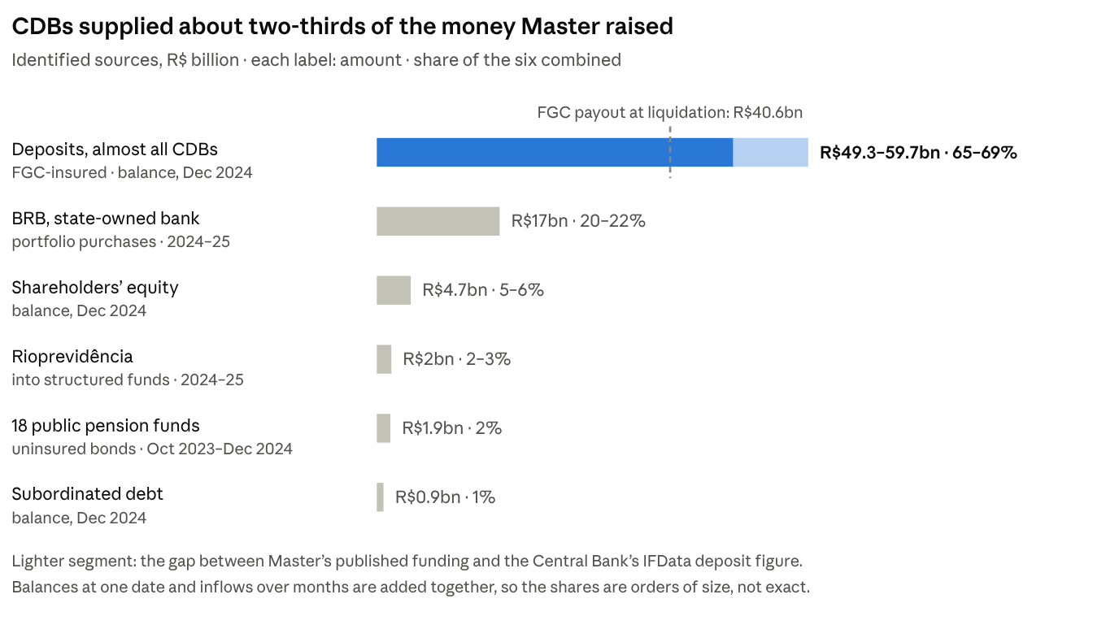
Master’s 2024 statements [115]; BC IFData via DIEESE [114]; PF, Ministry and FGC data via press [4][46][96][103] · balances at Dec 2024, inflows 2023–25
How to read it. The two deposit figures disagree. Master published R$49.3 billion in funding (time and interbank deposits) and R$63 billion in assets for 2024 [115]. The Central Bank’s IFData, compiled by DIEESE, shows more deposits, and its table implies a larger asset total than the note’s own text, unexplained [114].
The gap probably reflects the bank alone versus its wider group (author’s inference); the ranking holds either way. Not all deposits were outside money: loans to companies came back to the bank as purchases of its own CDBs [17].
Why the CDBs flowed. Four things moved them, and each fed the others.
- The guarantee. The FGC covered each saver up to R$250,000 [3]. Savers were trusting the fund, not the bank.
- The rate. Master paid up to 140% of the CDI, usually on five-year paper; the largest banks paid 100% or less [116].
- The sales force. Unnamed sources put cumulative sales at about R$26 billion through XP, R$6.7 billion through BTG and R$2.9 billion through Easynvest [116]. Advisers earned about 1.5% up front on a five-year CDB, against 0.6% on a two-year one [116]. XP says average adviser pay on fixed income is 0.3% a year [116].
- The pace. Deposits roughly doubled every year from 2021 to 2024, a sevenfold rise [114]. About 98% were time deposits, against 56–68% across the financial system [114].
One belt, several feeders. The sources arrived in sequence. Retail CDBs carried the growth from 2021 to mid-2024 [114]. Pension money arrived from October 2023, first as bonds, then through structured funds [96][103].
From 2024, BRB’s cash came in as earlier CDBs fell due [46]. It refinanced the pile more than it added to it (author’s inference from the timing; no document traces each real).
At the end. Insured CDBs were still the largest liability when Master failed: the FGC paid R$40.6 billion [4]. That is about two-thirds of the R$59.6 billion in deposits IFData showed for March 2025 [114]. The difference includes balances above the cap, deposits the FGC does not cover, and paper repaid before November (author’s arithmetic).

Who paid, and how
The FGC made the loss look private. In fact it was spread across bank customers, the Federal District’s budget and assets, and the pension budgets of 18 states and cities. Wherever the FGC’s cover stopped, the loss moved to whoever stood behind the creditor.
Who | What happened | Who ends up paying
Savers up to R$250,000 (about 800,000) | Repaid by the FGC from January 2026; balances stopped earning on the liquidation date [4][110] | Mostly made whole, minus the lost interest
Savers and firms above the cap; holders of uninsured paper | Wait in the liquidation queue and are paid only after priority creditors [111] | Themselves
Quota holders of Master-run real-estate funds | About R$610 million locked [95] | Themselves, for now
Will Bank and Banco Pleno clients | Covered by the FGC: R$6.3 billion and R$4.9 billion; Will’s payments were slow [108] | Mostly made whole
Public servants’ pension funds | Bonds uninsured; by law (Law 9.717/1998) states and cities cover pension shortfalls, with no extra charge on servants [97] | State and city budgets: taxpayers and public services
The Federal District, through BRB | A R$2.6 billion provision ordered by the Central Bank [51]; a first vote approving a loan of up to R$6.6 billion, with nine public properties available as collateral or for sale [107] | Federal District taxpayers and public assets
Bank customers in general | The FGC ordered banks to prepay five years of contributions, about R$32.5 billion [108]; an economist expects costlier credit, without an estimate [109] | The banks, and probably their borrowers
People whose names were used | Fake payroll loans in the names of people who never borrowed, reportedly including Bahia public-school teachers and a Federal District police officer [112][113] | Unknown

Where the readings diverge
Two questions remain genuinely open. The tables keep only evidence that points one way; a lavish lifestyle, for example, fits every reading and decides nothing.
When did the intent begin? (A) The bank was built to extract value from about 2019. (B) A real, aggressive business drifted into fraud as cash ran short.
Evidence | Points to | Origin
Fund-to-fund markups flagged from 2020 [12] | A | CVM
City fund paid R$419.9m to family companies in 2022 [26] | A | CVM filings; liquidator
Reag served Master from 2019 [21] | A | Plea proposal, uncorroborated
Organization structured since the last decade [30] | A | Federal prosecutors (SP)
Credcesta portfolio booked 45% above Master’s value [24] | B | BRB valuation
Model’s breakdown dated to November 2024 [15] | B | Central Bank
Tirreno shell created in December 2024 [46] | B (late escalation) | PF
Vorcaro says he swapped in his own assets below their value and asks for an independent appraisal [9] | B | Defense
Reading: A is ahead on dated extraction; B is not refuted, since some assets were real.
Who held control? (A) Vorcaro as leader, with subordinate partners. (B) A partnership with hidden financing.
Evidence | Points to | Origin
PF names Vorcaro leader; Lima in the executive-financial core [62] | A | PF indictment
In 2022, Master had three shareholders: Vorcaro, Lima and a Quadrado company [63] | B | Brazil Journal
Vorcaro, Lima and Quadrado jointly guaranteed a debenture debt [64] | B | Court dispute
Complaint says Tanure financed over R$700m in 2022 via convertible debentures [63] | B | Private complainant (Esh Capital)
Tanure denies any stake, including via options or debentures [65] | A | Tanure
Lima, said to have left in May 2024, met the Central Bank seven times in 2025 as Master’s CEO [66] | B | Central Bank public agenda
Reading: a small group with Vorcaro at the top is best supported; hidden control is contested.

How much rests on the phone
The defense’s challenge to Vorcaro’s phone threatens mainly the evidence of purpose and intent. Where the money came from and where it went rests largely on documents.
On October 29, 2026, the defense filed a report by its hired expert, Marcos Monteiro, on the phone seized at Vorcaro’s November 2025 arrest [92]. It says 657 files were modified and 436 created on November 18, 2025, hours after the arrest, with the phone in PF custody; counting later dates, 999 files changed, including the WhatsApp database [92].
The expert says the records cannot show who operated the phone or whether the changes were intentional, and that a USB connection may only have charged it [92]. No PF response was reported; the PF has asked for 60 more days of forensic work [92].
Finding | Main evidence | Exposed to the phone challenge?
FGC payout and liquidation | Official acts [4][10] | No
Questioned BRB portfolios | Central Bank audit, PF documents [46][48] | Mostly no
Family extraction (City, Navarra, Astralo 95) | CVM filings, liquidator, court freezes [26][89] | No
Amounts paid to the law firm, Metrópoles and Consult | Receita and Coaf data [34][35][74] | Amounts no; purpose yes
Dark Horse transfers | Freixo’s plea; a Coaf record [84][80] | Partly
Monthly payments to Nogueira; the resort and “KN” messages; A Turma | Mainly phone messages [33][72][76][58] | Yes
Pension-fund investments; the Castro link | Ministry registry and state audit court [96][98]; messages for the Castro link [99] | Amounts no; the Castro link partly
Lawyers interviewed in September disagreed on the annulment risk; one argued only tainted evidence would fall, while earlier or independent evidence would stand [93]. A loss on the phone would change what can be proven about intent in court, not the FGC payout or BRB’s provision.

What we don’t know, and what would settle it
Six open items could confirm or overturn this reading; until then, more searching mostly returns coverage of the same PF reports.
- The Reag founder’s plea. The PGR signed a plea deal with Mansur; it awaits approval [67], and his claim to trace R$20 billion of Vorcaro’s money stays an allegation until corroborated [68]. On October 27, the PGR asked the Supreme Court’s president for urgency [69].
- Who will rule. Since September 12, the Supreme Court’s president has held all Master case files; Justice Mendonça remains rapporteur but cannot act on them, and a redistribution is expected in November [94].
- The phone challenge. Whether courts accept the defense’s custody objections (previous section) [92].
- Inquiries beyond BRB. The October indictment comes from the first inquiry, centered on the BRB portfolios [8]. Reports on the Reag funds, Rioprevidência and the political payments are still pending.
- The liquidator’s valuations. They will show how much of the balance sheet was real. The CVM has opened a sanctioning process against the liquidator for missing a deadline to convene holders of three real-estate funds worth about R$610 million [95]; it concerns procedure, not the valuations.
- Charges and courts. Whether the PGR files charges, and whether the Supreme Court accepts them.
Two limits remain. The Central Bank kept its liquidation records confidential until November 2033 [70]. And whether the FGC amendment advanced in Congress was not checked here.

Method
- Sources. Press reports of documents from the PF, Central Bank, CVM, Receita Federal, Coaf, the liquidator, courts and plea deals, retrieved October 30–31, 2026. The primary documents themselves were not accessed.
- Labels. “Established” means an official act, or separate origins that agree. “Alleged” means a single investigating authority or a plea. Denials are reported where found.
- Concentration. Most findings trace to the PF. Where possible they are checked against separate origins: Receita data, Coaf alerts, the Central Bank’s public agenda, CVM filings and liquidator lawsuits.
- Legal status. An indictment or a plea allegation is not a conviction. Everyone named is presumed innocent.
- Inference. The “control fraud” reading, the tiers and the arithmetic are the author’s. The tiers rank documented function in the money engine, not guilt, fame or amount.
- Left out. A single-source report about a justice’s private conduct at a party, which adds nothing to the money analysis.
- Evidence tables. Actors, flows and a timeline are in the accompanying spreadsheet.

References
References 1–70 accessed October 30, 2026; 71–116 accessed October 31, 2026. “n.d.” = no date shown on the retrieved page.
- “Banco Central decreta liquidação extrajudicial do Banco Master.” Eu Quero Investir, n.d. link
- “Entenda a crise financeira por trás da compra do Banco Master pela BRB.” Jornal Opção, n.d. link
- Guide to FGC payments for Master CDB holders. Money Times, n.d. link
- “FGC paga R$ 40,6 bi a 800 mil investidores do Banco Master.” AUVP Analítica, n.d. link
- “FGC vai reembolsar 1,6 milhão de investidores do Banco Master.” Bora Investir (B3), Nov. 2025. link
- Akerlof, George A.; Romer, Paul M. “Looting: The Economic Underworld of Bankruptcy for Profit.” Brookings Papers on Economic Activity, 1993, no. 2. link
- “Editors’ Summary.” Brookings Papers on Economic Activity, 1993, no. 2. link
- “Caso Master: PF indicia 15, incluindo Vorcaro, por crimes financeiros.” Band, Oct. 28, 2026. link
- “Banqueiro do Master nega fraude e critica Banco Central.” SpaceMoney, Oct. 30, 2026. link
- “BC explica liquidação do Banco Master.” O Antagonista, Nov. 18, 2025. link
- “Banco Central impõe sigilo de 8 anos sobre caso Master.” Band, Apr. 6, 2026. link
- “CVM admite indícios de fraude no Banco Master desde 2020.” Revista Oeste, n.d. link
- Correio da Manhã, Jan. 15, 2026, p. 6 (print edition). link
- “Como funcionava o esquema do Banco Master, segundo a investigação.” IstoÉ, n.d. link
- “Como funcionava o esquema do Banco Master, segundo a investigação.” Band (with Deutsche Welle), Jan. 30, 2026. link
- Cerqueira, Felipe. “Banco Master é suspeito de inflar patrimônio com investimentos fraudulentos, diz CVM.” Jovem Pan, n.d. link
- “Investigação aponta uso de ‘laranjas’ em fundos do Banco Master.” Revista Oeste, n.d. link
- “Banco Central decreta liquidação da Reag Investimentos, envolvida no caso Master.” JOTA, Jan. 15, 2026 (via Harvard TagTeam). link
- “Entenda por que operações do Banco Master com a Reag estão sob investigação.” Jornal de Brasília, n.d. link
- “Como funcionava o esquema do Banco Master segundo a investigação.” Band, n.d. link
- “Ex-dono da Reag entrega à PGR proposta de delação premiada.” Poder360, n.d. link
- “Ex-dono da Reag propõe delação e cita Banco Master e PCC.” Itatiaia, n.d. link
- “Fundador da Reag confirma Master entre clientes e nega ligação com PCC.” Estadão Conteúdo via InfoMoney, n.d. link
- BRB’s valuation of assets received from Master (citing Valor Econômico). Let’s Money, n.d. link
- Mandl, Carolina; Felix, Diego. “Como Vorcaro desviava dinheiro do Master para familiares, segundo investigações.” Folhapress via Bem Paraná, n.d. link
- “Vorcaro tentou encobrir rombo de R$ 777 mi após usar Master para financiar empresas de familiares.” InfoMoney, n.d. link
- Rezende, Constança; Marchesini, Lucas. “Cunhado de Vorcaro recebeu R$ 485 milhões de empresa investigada pela PF em caso Master.” Folhapress via TNH1, Mar. 21, 2026. link
- On a Carbono Oculto fund’s R$180 million transfer to Super Empreendimentos. Folha de Pernambuco, n.d. link
- On R$2.2 billion allegedly hidden after release. BP Money, n.d. link
- On the São Paulo federal prosecutors’ view and the defense’s response. BP Money, n.d. link
- “PF: ex-chefe de supervisão do BC recebeu R$ 500 mil mensais de Vorcaro.” Folhapress via DGABC, n.d. link
- “PF aponta pagamentos de até R$ 400 mil por mês a agentes ligados ao caso Vorcaro.” Gazeta do Povo, n.d. link
- “Quem é Ciro Nogueira, senador e ex-ministro de Bolsonaro que foi alvo da PF.” CNN Brasil, May 7, 2026. link
- “Master repassou R$ 80 mi a escritório de mulher de Moraes, mostram documentos.” SBT News, n.d. link
- “Diálogos obtidos pela PF mostram repasse de R$ 51,9 mi de Vorcaro ao portal Metrópoles.” Estadão Conteúdo via Mercado & Consumo, Oct. 16, 2026. link
- “‘Comprado os caras’: Vorcaro pagou DCM para não criticar Master, diz PF.” Jovem Pan, n.d. link
- “Vorcaro ofereceu dinheiro para influenciadores criticarem o BC nas redes, segundo a PF.” Brasil de Fato, July 10, 2026. link
- Sampaio, Carlos Nathan. “Em delação rejeitada, Vorcaro associa doações a Tarcísio e Bolsonaro a propina.” Tribuna do Planalto, Sept. 4, 2026. link
- “Operação policial contra o crime organizado mira o Banco Genial e esquema ligado a recursos do filme Dark Horse.” Times Brasil, Sept. 24, 2026. link
- Senator Nogueira’s defense statement. IstoÉ Dinheiro, May 7, 2026. link
- Gayoso, Lucas. “PF encontra contrato de R$ 3 milhões por mês entre Vorcaro e escritório de Viviane de Moraes.” Correio da Manhã, Sept. 2026. link
- On three contracts totaling R$208 million. BP Money, n.d. link
- “Entenda o passo a passo da crise no STF.” Revista Oeste, n.d. link
- “Augusto Lima, ex-sócio do Master, tem ligações com o PT da Bahia.” Poder360, n.d. link
- “PF diz que BRB participou de fraudes em aportes bilionários no Banco Master.” BP Money, n.d. link
- Felix, Diego; Moura, Júlia. “Relatório da PF aponta que BRB comprou R$ 17 bi em créditos falsos do Banco Master.” Folhapress via Bahia Notícias, n.d. link
- “Saiba quem são os 15 primeiros indiciados pela PF sob suspeita de crimes no Banco Master.” TNH1, Oct. 29, 2026. link
- “‘Não há evidência de que as carteiras do Master eram podres’, diz ex-presidente do BRB.” Revista Oeste, n.d. link
- Sotero, Rafael. “Como funcionava esquema entre Ciro Nogueira e Daniel Vorcaro, segundo a PF.” CNN Brasil, May 7, 2026. link
- “Caso Master: veja os nomes e as condutas dos 15 indiciados no relatório da PF.” Sem Pauta News, Oct. 29, 2026. link
- “BC exige provisionamento de mais de R$ 2 bi do BRB por perdas com o Master.” Revista Oeste, n.d. link
- On the Central Bank’s estimate of BRB’s loss. Let’s Money, n.d. link
- “Fraudes do BRB e Master aconteceram mesmo sob olhar do BC.” Revista Oeste, n.d. link
- Côrtes, Gustavo; Sousa, Gabriel de; Ohana, Victor. O Estado de S. Paulo, Jan. 16, 2026, p. B2 (via ANFIP press clipping). link
- “Senador Ciro Nogueira é alvo de busca da PF no caso Master; primo de Vorcaro é preso.” Money Times, May 7, 2026. link
- On the PF’s fifth phase. Sul21, May 2026. link
- “Vorcaro simulou venda para Fictor para tentar fugir do país, dizem investigadores.” Jornal de Brasília, n.d. link
- “‘Sicários’ de Vorcaro presos pela PF formavam ‘milícia privada’.” Times Brasil, Mar. 4, 2026. link
- Bernardes, Alícia; Rocha, Danandra; Mac Cord, Iago. “PF: pai de Vorcaro chefiava milícia.” Correio Braziliense, May 15, 2026, p. 3. link
- “PF aponta que ‘Sicário’ recebeu R$ 24 milhões de Daniel Vorcaro.” Metrópoles, n.d. link
- “Defesa de Vorcaro pede que PF comprove existência da milícia ‘A Turma’.” Jornal Opção, Mar. 5, 2026. link
- “Saiba quem são os 15 primeiros indiciados pela PF sob suspeita de crimes no Banco Master.” Jornal de Brasília, Oct. 29, 2026. link
- On the Esh Capital complaint and Master’s 2022 shareholders. Brazil Journal, n.d. link
- “Do Master ao Voiter: entenda disputa judicial que envolve Augusto Lima.” Poder360, n.d. link
- “Quem é Nelson Tanure, que ganhou relógio de luxo de Vorcaro.” Jovem Pan, n.d. link
- “Augusto Lima, do Banco Pleno, se reuniu 7 vezes com BC em 2025 como CEO do Master.” Estadão Conteúdo via InfoMoney, n.d. link
- Rodrigues, Basília. “Caso Master: PGR assina delação com ex-dono da Reag.” SBT News, n.d. link
- Freire Neto, Moisés. “Delação de ex-dono da Reag põe R$ 20 bilhões do dinheiro de Vorcaro no radar.” Economic News Brasil, Sept. 10, 2026. link
- “Delação de Mansur, da Reag, ganha pedido de urgência da PGR a Fachin para localizar R$ 20 bilhões de Vorcaro.” Times Brasil, Oct. 27, 2026. link
- On the eight-year confidentiality of the liquidation records. BP Money, n.d. link
- On a PF report citing at least R$20 million to Toffoli’s family company. Metrópoles, Feb. 2026. link
- “Vorcaro teria sido pressionado por aportes em resort ligado a Toffoli e desembolsado R$ 35 milhões.” Times Brasil, Feb. 14, 2026. link
- “PF não mostra ao Supremo conteúdo de 52 celulares do caso Master.” Poder360, n.d. (search excerpt; on the justices’ view of the PF report on Toffoli). link
- Grandi, Guilherme; Manfrin, Juliet. “Filho de Nunes Marques teria recebido R$ 500 mil do Master, aponta PF.” Gazeta do Povo, Sept. 15, 2026. link
- “Vorcaro coordenou noitada em triplex para ministro do STF Kassio Nunes Marques, diz revista.” Estadão Conteúdo via O Liberal, Oct. 16, 2026 (cited only for the justice’s response). link
- Lobianco, Bianca. On the Carnival 2025 stay for “KN.” Correio da Manhã, Sept. 18, 2026. link
- “Conselho do MPF decide arquivar pedido de apuração sobre relação de Gonet e Vorcaro.” Times Brasil, Sept. 2026. link
- “Mensagem de Gonet para Vorcaro: ‘tomara que tenha charuto e Macallan’.” InfoMoney, Sept. 2026. link
- On Flávio Bolsonaro’s inclusion in the Dark Horse inquiry. O Hoje, Sept. 11, 2026. link
- “Flávio mentiu ao menos 43 vezes sobre elo com Vorcaro.” Aos Fatos, n.d. link
- “Nikolas admite contato com Vorcaro, mas nega relação: ‘nunca recebi nenhum tostão’.” Itatiaia, Sept. 3, 2026. link
- “Banco Master: quem são os dois empresários alvos da operação da PF, soltos pela Justiça.” Mercado & Consumo, Nov. 23, 2025. link
- “Banco Master: quem são os 15 indiciados pela PF no escândalo.” Revista Fórum, Oct. 29, 2026 (search excerpt). link
- On Justice Mendonça’s approval of Freixo’s plea. Gazeta do Povo, Sept. 2026. link
- On Costa’s statements about Ibaneis Rocha. Gazeta do Povo, July 9, 2026. link
- “STJ manda para PGR pedido de investigação sobre governador Ibaneis Rocha e caso Master.” SBT News, Feb. 4, 2026. link
- Gallo, Gabriela. “Vorcaro volta a negar que Master deu prejuízos financeiros ao BRB.” Correio da Manhã, Oct. 15, 2026. link
- “Vorcaro diz que crise no BRB é culpa de investigação da PF.” SBT News, Oct. 16, 2026. link
- “Justiça barra venda de bens ligados ao Banco Master após indícios de desvios.” Economic News Brasil, Mar. 18, 2026. link
- On the Miami penthouse transferred to Vorcaro’s ex-wife. Times Brasil, n.d. link
- “Exclusivo: Vorcaro obtém liminar nos EUA que suspende investigação sobre mansão de US$ 32 milhões.” SBT News, May 22, 2026. link
- “Perícia contratada por Vorcaro aponta alterações em celular de ex-banqueiro.” CNN Brasil, Oct. 29, 2026. link
- “Especialistas divergem sobre possibilidade de anulação do caso Master.” Itatiaia, Sept. 12, 2026. link
- “Ministro Edson Fachin retém processos do caso Master no STF e trava investigações.” Gazeta do Povo, Oct. 21, 2026. link
- “Alvo da CVM, liquidante do Master mantém R$ 610 milhões em FIIs travados.” NeoFeed, Oct. 21, 2026. link
- Souza, Amanda. “Banco Master: 18 fundos de previdência tinham investimentos no banco; veja lista.” Times Brasil, Nov. 19, 2025. link
- Queiroz, Vitória. “Estados e municípios vão arcar com rombo do Master em fundos de previdência.” CNN Brasil, Jan. 9, 2026. link
- “Cláudio Castro: relembre caso dos aportes bilionários do Rioprevidência no Master.” InfoMoney, May 26, 2026. link
- Muradi, Anna. “Cláudio Castro trocou cúpula do Rioprevidência antes de aportes de R$ 3,6 bilhões no Master, diz PF.” BP Money, May 26, 2026. link
- “Daniel Vorcaro bancou viagens de Cláudio Castro, diz PF.” CNN Brasil, May 26, 2026. link
- “Cláudio Castro agradeceu Vorcaro após jantar de R$ 66 mil em Nova York: ‘experiência incrível’.” Times Brasil, May 28, 2026. link
- “Castro nega relação indevida com Vorcaro e diz que contatos foram institucionais.” InfoMoney, May 27, 2026. link
- “PF: Rioprev investiu no Master para ‘contornar restrições’.” SBT News, May 2026. link
- “Entenda como o Rio investiu R$ 3 bi no Master e para onde foi o dinheiro.” CNN Brasil, May 2026. link
- “Vorcaro discutiu substituir aplicações do Rioprevidência por outros ativos antes da liquidação do Master.” Times Brasil, n.d. link
- On the Rio state attorney’s suits to recover R$641 million. Gazeta do Povo, July 2026. link
- “Câmara do DF aprova capitalização do BRB com garantia de imóveis públicos.” Itatiaia, Mar. 3, 2026. link
- “FGC antecipa contribuições de bancos para recompor R$ 32,5 bi do rombo deixado pelo Master.” SBT News, Mar. 5, 2026. link
- “Liquidações de bancos ligados ao Master devem encarecer crédito para o consumidor.” Diario de Pernambuco, Feb. 18, 2026. link
- “FGC deve começar a pagar investidores com CDBs do Master nesta semana.” InfoMoney, Jan. 2026 (search excerpt). link
- “FGC começa a ressarcir investidores do Banco Master.” Correio da Manhã, Jan. 2026 (search excerpt). link
- “Diretor do BC revela como identificou fraudes do Banco Master e créditos sem valor vendidos ao BRB.” SBT News, n.d. (search excerpt). link
- Correio da Manhã, Feb. 2, 2026, p. 6, print edition (search excerpt). link
- DIEESE. “Caso Banco Master: impactos sociais e implicações regulatórias.” Nota Técnica no. 291, Mar. 31, 2026 (tables from BC IFData). link
- Redação Suno. “Banco Master, em negociação com BRB, divulga balanço com lucro de R$ 1 bi em 2024.” Suno Notícias, Apr. 2, 2025. link
- Lucchesi, Cristiane; Piovesana, Matheus; Alvim, Leda. “Colapso do Banco Master levanta debate sobre papel de plataformas como a XP.” Bloomberg News via Bloomberg Línea, Dec. 1, 2025. link

